This Patient Group Direction (PGD) must only be used by registered community pharmacists who have been named and authorised by their organisation to practice under it. The PGD must only be used in conjunction with the local authority commissioned service specification for Emergency Contraception. The most recent and in date final signed version of the PGD must be used.

Patient Group Direction

for the supply and/or administration of

Levonorgestrel 1500 microgram tablets

by registered community pharmacists for

Emergency Hormonal Contraception

in Cheshire and Merseyside

Version number: 3.1

Effective From: June 1st 2019

Expires: May 31st 2022

Change History
Version number | Change details | Date
1 | Original version developed by Onyia, Mullin, Stubbs, Knight, Carrol, Geoghegan, Cartwright & Major – introduced in April 2014, expires March 31st 2016 | April 2014
2 | Completely reviewed and updated (February 2016) Takes into account NICE MPG 2 guidance & revised GMC prescribing guidance | March 2016
3 | Completely reviewed and updated in line with current evidence and best practice (see key references) | February 2019

PGD approval/ development
 | Name | Job title and organisation
Members of the PGD approval/development group | Olu Arikawe | Medicines Optimisation Lead Pharmacist, NHS Arden and GEM CSU
 | Dr Nicola Mullin | Consultant in Sexual and Reproductive Health, East Cheshire NHS Trust
 | Simon Bell | Public Health Commissioning Manager, Halton Borough Council
 | James Woolgar | Advanced Public Health Practitioner, Liverpool City Council
 | Cheryl Yeardsley | Project Officer, Champs Collaborative Support Team
 | Adam Major | Commissioning and Mobilisation Manager, Champs Collaborative Support Team
 | Nick Thayer | Pharmacy Services Manager, Community Pharmacy Cheshire & Wirral

PGD authorisation
Name |  | Job title and organisation | Signature | Date
Senior Pharmacist & Lead Author | Olu Arikawe  GPhC No: 2062262 | Medicines Optimisation Lead Pharmacist, NHS Arden and GEM CSU |  | 22/03/2019
Senior doctor | Dr Nicola Mullin  GMC No = 3547144 | Consultant in Sexual and Reproductive Health, East Cheshire NHS Trust |  | 22/03/2019
Person signing on behalf of authorising body | Dr Sandra Davies | Director of Public Health, Liverpool City Council |  | 24/05/2019
AGEM CSU Lead Pharmacist | Kym Lowder  GPhC 2031330 | Deputy AD Medicines Optimisation  Arden & GEM CSU | 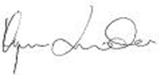 | 16/5/2019

Community Pharmacist agreement to practise under the
Levonorgestrel 1500 microgram tablets Patient Group Direction for Community Pharmacists
I have read and understood the Patient Group Direction and agree to supply and/or administer this medicine in accordance with this PGD

Name | GPhC Number | Signature | Date

Authorised to practice by Superintendent (or person acting on behalf of Superintendent)*
Full Name (print)
GPhC number
Signature
Date

* Has responsibility to ensure that only fully competent, qualified and trained professionals implement this PGD.
Agrees to maintain a current list of the names of individuals who may implement this PGD and to keep this with a pharmacy master copy of the PGD.
“Person acting on behalf of Superintendent” is usually the pharmacist Area or Branch manager.
Training and competency of registered community pharmacists
 | Requirements of registered community pharmacists working under the PGD
Qualifications and professional registration | Community Pharmacists currently registered with the General Pharmaceutical Council (GPhC), who are working in a pharmacy contracted to NHS England (Mersey) or NHS England (Cheshire, Warrington and Wirral).
Initial training | As a minimum requirement, this must be at the same level, covering the same learning objectives and competencies as the Centre for Pharmacy Postgraduate Education (CPPE) e-learning programme for emergency contraception and safeguarding (or subsequent updates to these trainings).
Competency assessment | The pharmacist must satisfy the requirements of Self-declaration of Competence (DOC) for Community Pharmacy for Emergency Contraception.  The Pharmacist should be able to demonstrate the competencies specified in NICE’s Competency Framework for Health Professionals using Patient Group Directions https://www.nice.org.uk/guidance/mpg2/resources
Ongoing training and competency | The pharmacist must maintain a regular self-assessment declaration of competency every two years or sooner if appropriate.  In addition to the statutory requirement for Continuing Professional Development (CPD), each pharmacist is expected to maintain an up to date awareness of developments in emergency contraception.  This PGD should be used with the current summary of product characteristics (SPC), British National Formulary (BNF) and Faculty of Sexual & Reproductive Healthcare (FSRH) clinical guidance- emergency contraception.

Clinical condition
Clinical condition or situation to which this PGD applies | Provision of emergency hormonal contraception (EHC) to women within 72 hours of unprotected sexual intercourse (UPSI) which may include suspected failure of a contraceptive method.
Inclusion criteria | - A woman of child bearing age AND presenting within 72 hours of UPSI.  - Can also include women presenting within 72 hours of UPSI with:  - failure of barrier or normal contraceptive method, e.g., a misplaced, dislodged, torn, removed or incorrectly inserted diaphragm; condom breakage /leakage /ejaculation on external genitalia; IUD (intrauterine device) complete or partial expulsion; miscalculation of fertility awareness method; missed or late contraceptive pill (further notes available in BNF chapter 7); see Appendix B for more information.  - OR severe diarrhoea and/or vomiting which may have reduced oral contraceptive efficacy.  - OR treated previously with levonorgestrel in the same cycle (see Cautions)  - Can be given in women presenting between 72-96 hours of UPSI (off-label recommendation from BNF and FSRH) for whom ulipristal acetate is either inappropriate or unavailable AND although an IUD has been recommended it is either refused or thought unlikely to be complied with. Use between 72-96 hours is outside the terms of the product license but is in line with clinical best-practice.  - Patient has received levonorgestrel emergency contraception but has vomited within three hours of taking it (provided they are still within 96 hours of UPSI).  Special notes on age  You may still supply the medication if it is in the best interests of the patient.  All patients under 18 years: A risk assessment should be undertaken to determine whether the child is at risk of harm. If you have a concern, the matter should be discussed with the local safeguarding lead.  All patients under16 years: Must be competent as assessed under the Fraser Guidelines on consent to medical treatment  All patients under 13 years: The matter must be discussed with the local safeguarding lead.  The pharmacist must be aware of their local safeguarding contact numbers for adults and children.
Exclusion criteria | - Woman unable to attend in person.  - Hypersensitivity to the active substance or any of the excipients (e.g. lactose, potato starch, maize starch, anhydrous colloidal silica, magnesium stearate and talc).  - Women with hereditary problems of galactose intolerance, lactase deficiency or glucose – galactose malabsorption problems.  - A woman presenting following most recent UPSI more than 96 hours ago (NB – IUD or ulipristal acetate may still be an option).  - No valid consent.  - Confirmed pregnancy.  - Acute active porphyria.  - Acute trophoblastic disease – seek specialist advice.  - Severe hepatic dysfunction.  - Postpartum patients (within 21 days) are not considered at risk of pregnancy and so are excluded from treatment.  - Ulipristal acetate has been taken by the patient within the last five days.  Check for any drug interaction (also see caution).
Cautions (including any relevant action to be taken) | - An IUD is the most effective means of post coital contraception and this option must be discussed with the woman. In instances where an IUD is acceptable to the woman, continue to supply levonorgestrel in case the IUD fitting is not done or proves unsuitable.  - If the last period was more than 4 weeks ago then a pregnancy test should be performed.  - Following termination of pregnancy, consider the date of termination as the last menstrual period.  - If levonorgestrel is used more than once in a cycle, advise the woman that she may have a delayed period or irregular bleeding.  - Severe malabsorption syndromes such as Crohn’s disease might impair the efficacy of levonorgestrel. Women with these conditions should be encouraged to consider an IUD as the preferred method of emergency contraception.  - Contraceptive efficacy can be reduced when the woman is currently taking or within 28 days of stopping griseofulvin and the following hepatic enzyme inducing medicines: anti-epileptics (e.g. carbamazepine, eslicarbazepine, oxcarbazepine, topiramate, phenobarbital, phenytoin, primidone, rufinamide); anti-TB drugs (e.g. rifampicin, rifabutin); anti-retrovirals (e.g. ritonavir efavirenz, nelfinavir, nevirapine); antidepressants (e.g. St John’s Wort –a herbal preparation); others (e.g. aprepitant, modafinil,bosentan).  . In this case, the woman should be offered a copper intrauterine device (IUD) which is considered to be more effective in this context. However, if the pharmacist feels that the suggestion of an IUD is unlikely to be acted upon, a higher dose (3 mg) can be offered instead.  - Unexplained vaginal bleeding.  - For more information on drug interaction, see the latest BNF and FSRH Drug Interactions with Hormonal Contraception
Arrangements for referral for medical advice | Know the referral pathway into local sexual and reproductive health services or how to contact the local lead doctor for sexual and reproductive health for medical advice.

Action to be taken if patient excluded | - Document exclusion criteria and discuss alternative measures.  - Discuss reasons for exclusions.  - Refer immediately to Community Sexual and Reproductive Health Clinic or GP if appropriate. An intrauterine device (IUD) may be fitted up to 5 days after unprotected intercourse or up to 5 days after likely ovulation.  - Consider supply and administration of ulipristal acetate if appropriate (refer to ulipristal PGD).  Warn the woman that a delay in starting treatment may compromise its efficacy.
Action to be taken if patient declines treatment | - Discuss reasons patient declines treatment.  - Consider the supply and/or administration of ulipristal acetate if appropriate.  - Refer immediately to Community Sexual and Reproductive Health Clinic or GP if appropriate.  - Record decision in the patient clinical record.

Details of the medicine
Name, form and strength of medicine | Levonorgestrel 1.5mg tablet
Legal category | POM (Prescription Only Medicine)
Off-label Use | The following recommendation from FSRH and BNF are off-label:  - Levonorgestrel can be given in women presenting between 72-96 hours of UPSI.  - The effectiveness of levonorgestrel could be reduced if a woman has a BMI >26 kg/m² or weight >70 kg. It is recommended that a double dose (3 mg) of levonorgestrel is given where ulipristal acetate is contraindicated or unavailable. Although it is unknown which is more effective, in this situation ulipristal acetate is the suitably licensed alternative, whereas 3mg levonorgestrel is outside of the current product license.
Route/method of administration | Oral route  Administration while the patient is present should be encouraged and supported, although this is voluntary.  If the tablet is not taken in the pharmacy, the woman should be advised to take it as soon as possible.
Dose and frequency | - One tablet (1.5mg) to be taken as soon as possible after UPSI.  - If vomiting occurs within THREE hours of taking the tablet, a second tablet should be taken immediately.  - If the woman is currently taking or within 28 days of stopping hepatic enzyme inducing drug(s) (see Cautions), then 3 mg (two tablets) should be taken.  - If the woman has a BMI >26 kg/m² or weight >70 kg, 3 mg of levonorgestrel should be taken where ulipristal acetate is contraindicated or unavailable. The woman should be advised that this is an off-label use but it is an advice from specialists (FSRH and BNF).
Quantity to be administered and/or supplied | Either  - One tablet to be taken as a single dose or  - Two tablets to be taken as a single dose if the woman is currently taking or within 28 days of stopping hepatic enzyme inducing drug(s) or  - Two tablets to be taken as a single dose if the woman has a BMI >26 kg/m² or weight >70 kg (off-label use) where ulipristal acetate is contraindicated or unavailable.
Maximum or minimum treatment period | As often as required as long as the patient meets the inclusion criteria. Although women returning for repeat dosage should be advised to seek a reliable ongoing method of contraception from their GP or Community Sexual and Reproductive Health Clinic.
Adverse effects | Common side effects include:- headache, nausea, lower abdominal pain, bleeding not related to menses and fatigue.  Less common side effects are:- dizziness, diarrhoea, vomiting, irregular menstruation, breast tenderness, and an alteration in the timing of the next period by more than seven days. However, if the next menstrual period is more than seven days overdue, pregnancy should be excluded.  Much less common side effects are abdominal pain, rash, urticaria, pruritus, pelvic pain, dysmenorrhoea and facial oedema.  This list is not exhaustive; refer to the current BNF and SPC for a detailed list.  Any serious adverse effects must be reported to the MHRA via the yellow card scheme.
Records to be kept  Records to be kept (continued) | - It is recommended that the following information should be recorded irrespective of whether a supply is made:  - Valid informed consent has been given  - Patient’s name, address (optional) and date of birth  - Relevant medical history  - Date of most recent UPSI  - Date of last menstrual period.  - Dose given  - Date of supply  - A record of the counselling about encouragement to consider an IUD  - Advice given  - Advice given if patient excluded or declines treatment  - Details of any adverse reactions and actions taken  - GPhC number and name of pharmacist who administered or supplied the medication  - Document if the dose is administered on the premises  - The supply must be entered in the Patient Medication Record (PMR) indicating a PGD.  - All records should be clear, legible and contemporaneous.  This can be recorded via a paper or electronic version (or both)  - A “Fraser Ruling Assessment of Competency” form must be completed for all women under 16 years of age  * The Human Medicines Regulations 2012 confirms that in the case of supply of oral contraception, the requirements for recording information are relaxed. It is therefore reasonable for pharmacists to exert their professional judgement when supplying a woman with EHC who does not wish to provide any information.

Patient information
Written information to be given to patient or carer | Give copy of the patient information leaflet and discuss as required e.g. failure rate (1-3 women out of 100 will become pregnant despite taking EHC. An IUD has negligible failure rate).  Supply woman with appropriate leaflets and information about local Sexual and Reproductive Health Services
Follow-up advice to be given to patient or carer | - Stress the need to use a reliable ongoing method of contraception.  - Explain other available treatment option including an IUD.  - Advise the patient that the drug given at this consultation for this episode of UPSI, will have no effect for previous risks (UPSI) i.e. more than 72 hours ago.  - Advise that if vomiting occurs within 3 hours of taking levonorgestrel to immediately return to the pharmacy or seek advice from a Community Sexual and Reproductive Health clinic or GP.  - Advise patient that she could still become pregnant. If next period is delayed by more than 7 days or is abnormal in any way (light, heavy or painful), woman should seek medical advice.  - In women using bridging (follow on) contraception, stress the need to use additional barrier methods for the requisite number of days (dependent on method).  - If a pregnancy has occurred, following failure of levonorgestrel treatment, the patient should contact a Community Sexual and Reproductive Health clinic or GP for further advice.  - Seek medical advice if there is any lower abdominal pain because this could signify an ectopic pregnancy.  - Advise that the patient may be at risk of sharing sexually transmitted infections (STIs) and the need for condom use. Patients may be asymptomatic. Further advice, screening and treatment can be accessed from Community Sexual and Reproductive Health Services or their GP.  - If further dose(s) are given in the same cycle, the woman should be advised that levonorgestrel may cause disturbance of subsequent cycles. Repeated administration is not advisable because of this possibility.  - According to FSRH, the use of levonorgestrel is not contraindicated during breastfeeding. The SPC for Levonelle advises that LNG is secreted into breast milk and that potential exposure of the infant to levonorgestrel can be reduced if the woman takes the tablet immediately after feeding and avoids nursing for at least 8 hours. However studies report no evidence of an adverse effect on the infant or on lactation and that women can be advised to continue to breastfeed after using levonorgestrel. For individuals who are reluctant to comply with this, the option of having an IUD should be discussed as an alternative.  - Emergency contraception is an occasional method. It should in no instance replace a regular method of contraception.  - There is no evidence to date that the hormones used postcoitally carry any risk of teratogenicity should the method fail and a pregnancy occur.  - Advise that when given between 72-96 hours when ulipristal acetate is inappropriate (and an IUD has been refused) is outside the product licence. Although the Faculty of Sexual and Reproductive Healthcare support this indication, warn that an IUD is much more effective.

APPENDICES
Appendix A: Key References (accessed February 2019)
Faculty of Sexual & Reproductive Healthcare Guideline: Emergency contraception. London, Clinical Effectiveness Unit March 2017 (updated December 2017)
https://www.fsrh.org/standards-and-guidance/documents/ceu-clinical-guidance-emergency-contraception-march-2017/

Faculty of Sexual & Reproductive Healthcare Clinical Guideline: Drug Interactions with Hormonal Contraception. London, Clinical Effectiveness Unit, January 2018
https://www.fsrh.org/documents/ceu-clinical-guidance-drug-interactions-with-hormonal/

Faculty of Sexual & Reproductive Healthcare Guideline: Quick Starting Contraception. London, Clinical Effectiveness Unit March 2017 (April 2017)
file:///C:/Users/OArikawe/Downloads/1fsrh-guideline-quick-starting-contraception-april-2017%20(1).pdf

Electronic Medicines Compendium. Summary of Product Characteristics: Levonelle® 1500 microgram tablet. Leatherhead, eMC (Bayer), March 2018.
https://www.medicines.org.uk/emc/product/133/smpc.

Online British National Formulary, Levonorgestrel London, Pharmaceutical Press, October 2018. www.bnf.org

General Medical Council. Good practice in prescribing and managing medicines and devices. London: GMC, 2013 (updated 2014)
http://www.gmc-uk.org/Prescribing_guidance.pdf_59055247.pdf
National Institute for Health and Care Excellence. Medicines Practice Guideline 2:
Patient Group Directions. London: NICE, 2013 (updated March 2017).
https://www.nice.org.uk/guidance/mpg2/resources/patient-group-directions-pdf-1779401941189

National Institute for Health and Care Excellence. Public health guideline 51: Contraceptive services for under 25s. London: NICE , 2014
https://www.nice.org.uk/guidance/ph51/resources/contraceptive-services-for-under-25s-1996413367237

Appendix B
Indications for emergency contraception following potential failure of hormonal and intrauterine methods of contraception
Method | Situation leading to possible contraceptive failure | Indication for EC
Hormonal methods of contraception | Failure to use additional contraceptive precautions when starting the method | UPSI or barrier failure during time that additional precautions required as indicated within CEU guidance.
Combined hormonal transdermal patch or combined hormonal vaginal ring | Patch detachment/ring removal for >48 hours  Extension of patch-free or ring-free interval by >48 hours | EC is indicated if patch detachment or ring removal occurs in Week 1 and there has been UPSI or barrier failure during the hormone-free interval (HFI) or Week 1.  If the HFI is extended, a Cu-IUD can be offered up to 13 days after the start of the HFI assuming previous perfect use.  If CHC has been used in the 7 days prior to EC, the effectiveness of UPA-EC could theoretically be reduced. Consider use of LNG-EC.
Combined oral contraceptive pill (monophasic pill containing ethinylestradiol) | Missed pills (if two or more active pills are missed) | EC is indicated if the pills are missed in Week 1 and there has been UPSI or barrier failure during the pill-free interval or Week 1.  If the pill-free interval is extended (this includes missing pills in Week 1), a Cu-IUD can be offered up to 13 days after the start of the HFI assuming previous perfect use.  If COC has been taken in the 7 days prior to EC, the effectiveness of UPA-EC could theoretically be reduced. Consider use of LNG-EC.
Combined hormonal contraception, progestogen-only pill and progestogen-only implant | Failure to use additional contraceptive precautions whilst using liver enzyme-inducing drugs or in the 28 days after use | EC is indicated if there is UPSI or barrier failure during, or in the 28 days following, use of liver enzyme-inducing drugs. Offer a Cu-IUD (unaffected by liver enzyme-inducing drugs) or a double dose (3 mg) of LNG-EC. UPA-EC is not recommended in this situation.
Progestogen-only pill | Late or missed pill (>27 hours since last traditional POP or >36 hours since last desogestrel-only pill) | EC is indicated if a pill is late or missed and there has been UPSI or barrier failure before efficacy has been re-established (i.e. 48 hours after restarting).  Timing of ovulation after missed pills cannot be accurately predicted. A Cu-IUD is therefore only recommended up to 5 days after the first UPSI following a missed POP.  If POP has been taken in the 7 days prior to EC, the effectiveness of UPA-EC could theoretically be reduced. Consider use of LNG-EC.
Progestogen-only injectable | Late injection (>14 weeks since last injection of DMPA) | EC is indicated if there has been UPSI or barrier failure:  >14 weeks after the last injection  within the first 7 days after late injection  Timing of ovulation after expiry of the progestogen-only injectable is extremely variable. A Cu-IUD is only recommended up to 5 days after the first UPSI that takes place >14 weeks after the last DMPA injection.  The effectiveness of UPA-EC could theoretically be reduced by residual circulating progestogen. Consider use of LNG-EC.
Progestogen-only implant | Expired implant | Women can be advised that the risk of pregnancy in the fourth year of use of the progestogen-only implant Nexplanon and the sixth year of use of the 52 mg LNG-IUS Mirena® is extremely low. The effectiveness of UPA-EC in the presence of progestogen from a recently expired IMP or LNG-IUS is unknown. Clinicians may consider use of LNG-EC in this situation with immediate quick start of appropriate hormonal contraception. If UPA-EC is given, hormonal contraception should not be started/restarted for 5 days after the UPA-EC has been taken.
Intrauterine contraception (Cu-IUD and LNG-IUS) | Removal without immediate replacement; partial or complete expulsion; threads missing and IUC location unknown | If UPSI has taken place in the 7 days prior to removal, perforation, partial or complete expulsion. Oral EC is indicated if there has been UPSI in the last 5 days. Depending on the timing of UPSI and time since IUD known to be correctly placed, it may be appropriate to fit another Cu-IUD for EC.

CEU, Clinical Effectiveness Unit; CHC, combined hormonal contraception; COC, combined oral contraception; Cu-IUD, copper intrauterine device; DMPA, progestogen-only injectable: depot medroxyprogesterone acetate; EC, emergency contraception; HFI, hormonal-free interval; IMP, progestogen-only implant; IUC, intrauterine contraception; LNG-EC, levonorgestrel for EC; LNG-IUS, levonorgestrel-releasing intrauterine system; POP, progestogen-only pill; UPA-EC, ulipristal acetate for EC; UPSI, unprotected sexual intercourse.
Reproduced under licence from FSRH and the notice Copyright ©Faculty of Sexual and Reproductive Healthcare December 2017

Appendix C: Advice to Young People Under 16
In considering the provision of advice or treatment on contraception, doctors and other professional staff need to take special care not to undermine parental responsibility and family stability. The doctor or other professional should therefore always seek to persuade the young person to tell the parents or guardian (or other person in loco parentis), or to let her inform them, that contraceptive advice is being sought and the nature of any advice or treatment that is given. It should be most unusual for a doctor or other professional to provide advice or treatment in relation to contraception to a young person under 16 without parental knowledge or consent.

Exceptionally, there will be cases where it is not possible to persuade the young person either to inform the parents or to allow the doctor or other professional to do so. This may be, for example, where family relationships have broken down. In such cases, a doctor or other professional would be justified in giving advice and treatment without parental knowledge or consent, provided they followed the Fraser Guidelines.

FRASER GUIDELINES
In law young people under 16 years are entitled to confidentiality in the same way as over 16 year olds. In 1985 Lord Fraser established the current legal position that a doctor or other professional can give contraceptive advice or treatment to a person under 16 without parental consent providing they are satisfied that:

- The young person will understand the risks and benefits of the treatment offered and the advice given.
- The young person cannot be persuaded to tell his or her parents or allow a health professional to inform them that he or she is seeking contraception advice.
- The young person is likely to begin or continue having intercourse with or without contraceptive treatment.
- Unless he or she receives contraceptive advice the young person’s physical or mental health is likely to suffer.
- It is in the young person’s best interests to give them contraceptive advice or treatment.

Reference Gillick v West Norfolk & Wisbech Area Health Authority (1984) AC 1121 ALL ER

- Where there are concerns about children and young people’s welfare appropriate actions should be taken to address those concerns, working to agreed local policies and procedures. Refer to Safeguarding Children Flow Chart for Referral.

MEDICoLEGAL ASPECTS
Medical legal aspects regarding supply to under 16 year olds

- It’s illegal for them to be having sex
Answer: It is illegal for a man to have sexual intercourse with a girl under age 16 years. The girl is not committing any offence. The historical background to this Act was the need to have some structure to prevent child prostitution.

- You are aiding and abetting an illegal act
Answer: Taking action after an event to minimise its ill consequences cannot be interpreted as aiding and abetting-any more than the investigation and treatment of sexually transmitted infection would be.

The medical Defence Union opinion is that aiding and abetting would only be involved if a person actually were present at the time of the sexual intercourse and was encouraging it.

- The Age of Consent is 16 years
Answer: In English Law the validity of consent depends upon the capacity of the person to understand. The House of Lords considered the specific case of consent to contraceptive treatment in a ruling (Gillick v West Norfolk and Wisbech Area Health Authority and the Department of Health and Social Security, delivered October 1989). Attached is the advice which was issued after this by the Department of Health in the Handbook of Contraceptive Practice 1990 edition, pages 92 and 93.

Note that the exceptional nature of providing emergency contraception under protocol to young persons under 16 is confirmed by the actual numbers seen and considered under the protocol, compared to the numbers of older women.

Note also the young person is fully entitled to confidentiality. The guidance in paragraph 2 is that a doctor or other professional should always seek to persuade the young person to tell, or to permit to inform. No information should be given without the young person’s consent and consent to disclosure given under pressure or undue persuasion would not be valid.

The pharmacists training package includes a role play of the type of discussion which is valid and appropriate.

- It shouldn’t be allowed for the very young, it will just encourage them
Answer: Note that there is a lower age limit for sale of alcohol and for sale of cigarettes, but no lower age limit for the sale of condoms. Any deterrent effect in differential use is not immediately obvious!!

Rosemary Kirkman
Senior Lecturer in Family Planning, University of Manchester
Hon Consultant, Mancunian Community Family Planning Services

Contraceptive advice and treatment for young people under 16
(HN(81)5/LASS(81)2 has now been replaced by the following text which forms the Appendix to
HC(86)1/HC(FP)(86)1/LAC(86)3 “Family Planning Services for Young People” issued in March 1986 – this also applies to England and Wales only).

1. The following guidance draws the attention of health authorities and others concerned to the considerations doctors and other professionals need to have in mind when providing contraceptive advice and treatment to young people under 16, and to the circumstances in which such advice and treatment can be given without parental knowledge or consent. The guidance results from a review of that in Section G of the Memorandum of Guidance on the Family Planning Service, as specified in the Appendix to HN(81)5 and LASSL(81)2, in the light of the House of Lords, decision in the case of Gillick v West Norfolk and Wisbech Area Health Authority and the Department of Health and Social Security delivered last October.

2. In considering the provision of advice or treatment on contraception doctors and other professional staff need to take special care not to undermine parental responsibility and family stability. The doctor or other professional should therefore always seek to persuade the young person to tell the parents or guardian (or other person in loco parentis)*, or to let him inform them, that contraceptive advice is being sought and the nature of any advice or treatment that is given. It should be most unusual for a doctor or other professional to provide advice or treatment in relation to contraception to a young person under 16 without parental knowledge or consent.

3. Exceptionally, there will be cases where it is not possible to persuade the young person either to inform the parents or to allow the doctor or other professional to do so. This may be, for example, where family relationships have broken down. In such cases, a doctor or other professional would be justified in giving advice and treatment without parental knowledge or consent, provided they were satisfied:

- that the young person could understand their advice and had sufficient maturity to understand what was involved in terms of the moral, social and emotional implications;

- that they could neither persuade the young person to inform the parents, nor to allow them to inform them, that contraceptive advice was being sought;

- that the young person would be very likely to begin, or continue having, sexual intercourse with or without contraceptive treatment;

- that without contraceptive advice or treatment, the young person’s physical or mental health, or both would be likely to suffer;

- that the young person’s best interests require them to give contraceptive advice, treatment or both without parental consent.

4. Decisions about whether to prescribe contraception in such cases are for a doctors clinical judgement, if a doctor who is not the young person’s general practitioner has formed the view, after due consideration of the points made above, that it is in the best interest of the young person to prescribe contraception without parental knowledge or consent, it may be advisable and helpful for them, with the young person’s agreement, to discuss the matter in confidence with her own general practitioner before making his decision.
5. In organising contraceptive services for young people, health authorities may find it helpful to make separate, less formal arrangements that those for older age groups. The staff should be experienced in dealing with young people and their problems.

*Where the parental rights and duties in respect of a young person are vested in the local authority (by virtue of a care order or a parental rights resolution under Section 3 of the Child Care Act 1980) the authority must be treated as the young person’s parents for the purposes of giving consent to medical treatment in respect of a young person under 16. Where the authority does not have parental rights, the natural parent’s rights are not affected. Where a young person has been committed to the care of a local authority under wardship proceedings, the consent of the High Court must be obtained by the local authority. Where a local authority shares the parental rights and duties with another person, the consent of the local authority is sufficient unless the other person indicates an objection.

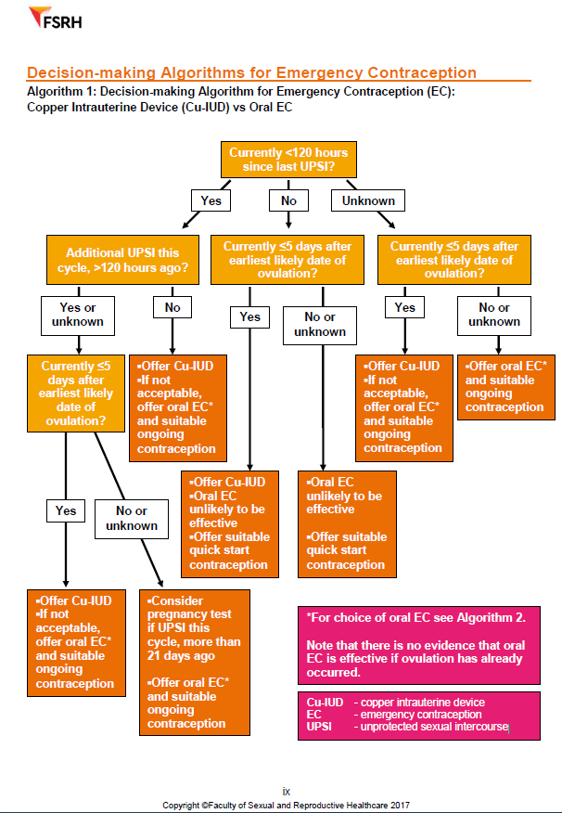
Appendix D

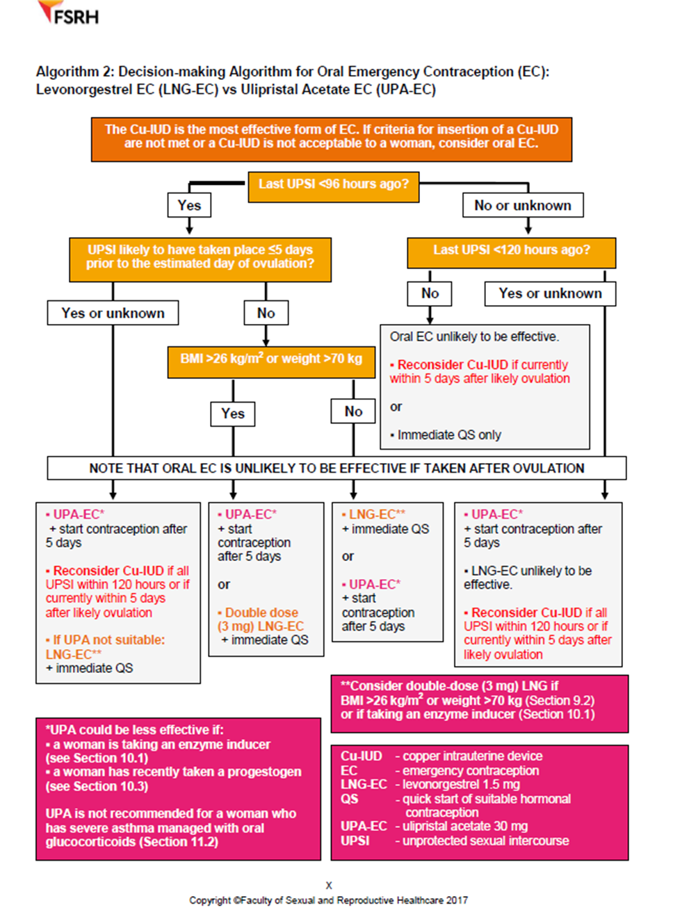

governance or safety lead of the Local Authority , usually the Director of Public Health or Chief Executive
http://www.legislation.gov.uk/uksi/2012/1916/regulation/253/made, paras 1,2,3 & 4

