Vaccination Training 2019
Sefton LPC and Sonar Informatics would like to invite you to attend practical vaccination training for Flu, Travel & other PGDs.
We are offering Flu vaccination training at a reduced price of £79+vat.

Book Training Now: www.sonarinformatics.com/training
or email us: info@sonarinformatics.com
[ ] Flu face-to-face Training | £99 + VAT
[ ] Flu refresher Training (online if you trained last year) | £29+ VAT
[ ] Travel Clinic Training Includes PGDs for: Cholera, DTP, hepatitis A, hepatitis B, hepatitis A+B (combined), hepatitis A + typhoid (combined), Japanese B encephalitis, malaria prophylaxis, meningitis ACWY, jetlag, rabies, tick-borne encephalitis, travellers’ diarrhoea, typhoid and yellow fever** | [ ] £369+ VAT for 1st Pharmacist
 | [ ] £199+VAT for 2nd Pharmacist

[ ] Training Date: Monday 24th June 2019
Time: 07:00PM–10:30PM
Location: Village Hotel Liverpool, Fallows Way, Whiston, Liverpool, L35 1RZ
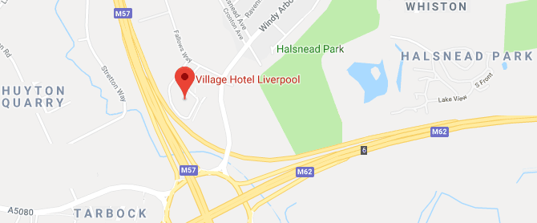
[ ] Training Date: Sunday 11th August 2019
Time: 1:00pm-4:30pm
Location: Holiday Inn Runcorn, Wood Lane, Beechwood, Cheshire, Runcorn, WA7 3HA
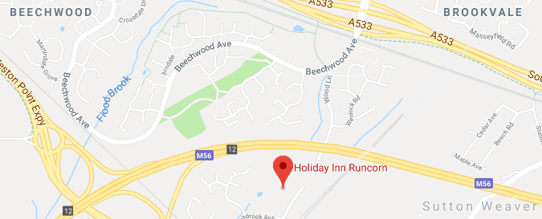

Vaccination Training 2019
Sefton LPC and Sonar Informatics would like to invite you to attend practical vaccination training for Flu, Travel & other PGDs.
We are offering Flu vaccination training at a reduced price of £79+vat.

Book Training Now: www.sonarinformatics.com/training or email us: info@sonarinformatics.com
[ ] Flu face-to-face Training | £99 + VAT
[ ] Flu refresher Training (online if you trained last year) | £29+ VAT
[ ] Travel Clinic Training Includes PGDs for: Cholera, DTP, hepatitis A, hepatitis B, hepatitis A+B (combined), hepatitis A + typhoid (combined), Japanese B encephalitis, malaria prophylaxis, meningitis ACWY, jetlag, rabies, tick-borne encephalitis, travellers’ diarrhoea, typhoid and yellow fever** | [ ] £369+ VAT for  1st Pharmacist
[ ] £199+VAT for
2nd Pharmacist

[ ] Training Date: Sunday 4th August 2019 Time: 10am-4pm

Location: Princess St. Hotel 18-24 Princess St, Manchester M1 4LG
